A **burn down chart** is a graphical representation of work left to do versus time. The outstanding work (or backlog) is often on the vertical axis, with time along the horizontal. That is, it is a [run chart](https://en.wikipedia.org/wiki/Run_chart) of outstanding work. It is useful for predicting when all of the work will be completed. It is often used in [agile software development](https://en.wikipedia.org/wiki/Agile_software_development) methodologies such as [Scrum](https://en.wikipedia.org/wiki/Scrum_(development)). However, burn down charts can be applied to any project containing measurable progress over time.

Outstanding work can be represented in terms of either time or story points.

As my opinion:burn down chart is a type of tool that show us a kind of relationship between time and the rest work.We can use this chart to check the process of work and

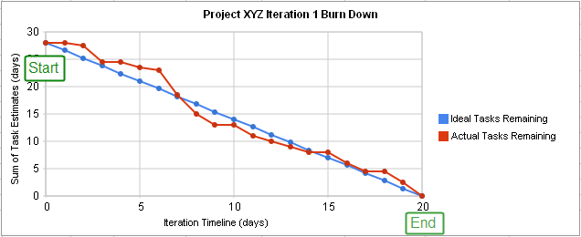

A project burn down chart[2]

X-Axis：The project/iteration timeline

Y-Axis：The work that needs to be completed for the project. The time or story point estimates for the work remaining will be represented by this axis.

Project Start Point：This is the farthest point to the left of the chart and occurs at day 0 of the project/iteration.

Project End Point：This is the point that is farthest to the right of the chart and occurs on the predicted last day of the project/iteration

Ideal Work Remaining Line：This is a straight line that connects the start point to the end point. At the start point, the ideal line shows the sum of the estimates for all the tasks (work) that needs to be completed. At the end point, the ideal line intercepts the x-axis showing that there is no work left to be completed. Some people take issue with calling this an "ideal" line, as it's not generally true that the goal is to follow this line. This line is a mathematical calculation based on estimates, and the estimates are more likely to be in error than the work. The goal of a burn down chart is to display the progress toward completion and give an estimate on the likelihood of timely completion.

Actual Work Remaining Line：This shows the actual work remaining. At the start point, the actual work remaining is the same as the ideal work remaining but as time progresses, the actual work line fluctuates above and below the ideal line depending on how effective the team is. In general, a new point is added to this line each day of the project. Each day, the sum of the time or story point estimates for work that was recently completed is subtracted from the last point in the line to determine the next point.

There are 7 situation of burndown charts:

1.Fakey-fakey:it is difficult to create a direct aim due to the complex project.

2.Late-Learner:there will be a peak,and it usually appears at teams which are learning Scrum.

3.Middle-Learner:it is more better than Late-Learner.Teams will find out most of the task and complication when they are in middle of Sprint

4.Early-Learner:there is a peak at the beginning,and then it goes down

5.Plateau:teams make a big process at the beginning but miss the direction at the last part of Sprint

Trello:

This is a tool that give us a convenient way to cooperate in teams.We can use some elements in it.For example,we can use “card” to record some information and tasks.Besides,we can use “list” to save “card” and use “board” to save “list”.Trello can create many tasks and change some of their states.

[User stories](http://www.amazon.com/exec/obidos/ASIN/0321205685/ambysoftinc/)

are one of the primary development artifacts for Scrum and Extreme Programming (XP) project teams. A user story is a very high-level definition of a requirement, containing just enough information so that the developers can produce a reasonable estimate of the effort to implement it.

In [software development](https://en.wikipedia.org/wiki/Software_development) and [product management](https://en.wikipedia.org/wiki/Product_management), a **user story** is a description consisting of one or more sentences in the everyday or business language of the [end user](https://en.wikipedia.org/wiki/User_(computing)#End-user) or [user of a system](https://en.wikipedia.org/wiki/User_(system)) that captures what a user does or needs to do as part of his or her job function. User stories are used with [agile software development](https://en.wikipedia.org/wiki/Agile_software_development) methodologies as the basis for defining the functions a business system must provide, and to facilitate [requirements management](https://en.wikipedia.org/wiki/Requirements_management). It captures the 'who', 'what' and 'why' of a requirement in a simple, concise way, often limited in detail by what can be hand-written on a small paper notecard.

A user story encapsulates the action of one function making it possible for software developers to create a [vertical slice](https://en.wikipedia.org/wiki/Vertical_slice) of their work.